Big Data Tools & Analytics

# Group Members:

Luke Gorman l59059

Mark O’Shea l58930

Efe Turkselci l58418

# Data Set:

Movie Industry data scraped from the international movie database (IMDB). This is large dataset that has over 6500+ movies and 16 distinct categories for us to carry out analysis. This data set is available on Kaggle for our analysis.

# Questions:

Outside of America which countries produce highly rated films on average, where are Hollywood’s biggest competitors?

What is the growth in average budget year over year. Has the budget of movies increased over time?

Which directors have the highest ratings and gross the most amount of money with creating over 6 movies, that are in these top 200 movies in each year?

Does the average run time (duration) influence movie ratings and revenue, along with budget, is there an optimal run time for movies?

What studios earn the highest gross and what genre of film is the most popular?

We can also calculate our own columns for example we can work out the profit of each film by subtracting the budget from the revenue.

Contents

Group Members: 1

Data Set: 1

Questions: 1

Introduction 3

Directors 4

Top 10 Directors based on average rating with 15 or more movies 4

Top directors average budget 5

Top directors average gross 6

Top Directors based on Percentage Profit 7

Top Directors based on profit percentage with 10 movies or more 8

Countries 9

Top performing countries outside of USA based on Score (50 or more movies) 9

Percentage profit of the top performing countries outside the USA 10

The Change in Budget and Gross overtime 11

Relationship between runtime and other variables 12

Relationship between score and runtime 12

Relationship between runtime and Budget 13

Relationship between runtime and Gross 14

Average rating per year 15

Companies 16

Which companies have taken the most gross revenue for the last 40 years? 16

Top 10 companies based on production 17

Top companies gross on average with 50 or more movies 18

The top 10 companies with the largest on average budget with 50 or more movies 19

Average Percentage Profit for all companies with 50 or more movies 20

Genres 21

What genre is most dominant in terms of movies being made? 21

1980-2020 21

2000-2020 22

2015 – 2020 23

Conclusion 24

# Introduction

The dataset we decided to analyse in this project was one to do with movies. The dataset consists of the top 200 movies over the last 40 years dating up to 2020. However, 2020 was quite faulty when it comes to data quality, so we decided to not include it for the most part unless small parts were needed which were fully complete. We decided to focus on movies as all of us were very interested in it and we felt we had a natural curiosity about questions that we could answer through our analysis. We decided to use Power bi as our tool for creating visuals and cleaning data as we are familiar with this tool and felt it would be more efficient.

Originally, we had some data cleaning to do ourselves as the dataset came with no headings and had other problems that needed to be dealt with. What we will outline in this project is analysis on topics such as:

* Directors
  + Who generates the most revenue along with who has the most budget to work with on average.
  + Who generates the highest rating on average with a certain number of movies created.
  + Who created the most percentage profit on average, will have to create a calculated column to complete this section
* Countries
  + Which countries are top performing based on rating on average.
  + Similarly, we wanted to find the average percentage profit for these countries, with a certain amount of movies created to remove countries with a small movie count.
* What effect does the runtime of movies have on other aspects
  + The effect runtime has on the rating.
  + The effect runtime has on the budget.
  + The effect runtime has on the revenue.
* How has the budget and revenue changed over this period.
* Companies
  + What company has the biggest budget on average.
  + What company has the biggest revenue on average.
  + What company creates the most movies over this 40-year period. Does this influence the first two questions

# Directors

## Top 10 Directors based on average rating with 15 or more movies

Here we see the top 10 directors. We used a limit of a minimum of 15 movies over the past 40 years as we wanted to see who really the top performing director would be. The reason we used the minimum number to be 15 movies is that we felt that making a movie every 2-3 years, in our minds makes a director a top director. Using the above diagram as a focal point we are going to just use these directors for the beginning. With these directors we want to see out of these 10 who has the most budget on average, who has the most gross per movie and finally which results in the highest percentage profit. After this we will also reduce the movie limit to see how much it will change the diagram. We will change it from 15 movies to just 10 to see if their other directors who should be in the conversation.

The above diagram has the order of directors with best rating on average. This is not a customer-based score but rather from IMDB (the Internet Movie Database). The line that is highlighted within the diagram also refers to the number of movies to give a bit more context. The line refers to the Y axis on the right-hand side, for example Martin Scorsese would have 19 movies created. Interestingly it is one of the lowest in the top 10. To look at this objectively we could say Woody Allen would be one of the more impressive directors looking at this diagram as he has created 38 movies in the same time. This is double what Martin Scorsese has created which is very impressive. But to dig deeper into these directors we really need to investigate the budgets, gross, and finally percentage profit.

## 

## Top Directors average budget

In this diagram we see the same directors presented in terms of their average budget. The order has changed massively which is interesting. Woody Allen is at the bottom of the list, although some his movies are old starting from 1983, there many movies that are made within the last 20 years. Interestingly we see that his highest budget for a movie is 32 million and leaves his average just slightly over 17 million. With that many movies being made, having the ability to create an average budget very low relative to others is very impressive and a cool insight. At the opposite end of the scale, we see Tim Burton with an average budget of just over 75 million. We see a 331% increase from Woody Allen to Tim Burton which is an extremely high change. We can see some of his movies such as Charlie and the chocolate factory and many more have a budget of over 100 million which is astonishing. We found this diagram very insightful, even seeing Martin Scorsese from first to fifth which is also just highlighting how impressive of a director he is, as he can create more value from the budget that he has on average.

There is a split within the diagram from the top 5 to the bottom five as we see a massive jump from Joel Schumacher to Martin Scorsese. We see a 35 million average jump to 59 million which is interesting, and we are interested to see if this will relate to the gross also.

## Top Directors average gross

In this diagram we see the same directors again, this time with the average gross per movie. We were surprised to see Woody Allen at the bottom of the list. Firstly, we thought that there must be a mistake in the data, however when we investigated it, according to the data we see that many of his movies brought in quite a small profit percentage which was very surprising, and we are curious to see just how much profit percentage he will display. We have assumed that he will be last again.

Again we wanted to show the percentage increase from the highest gross on average vs the lowest gross on average and we see Woody Allen’s gross at 28 million climb to Steven Spielberg’s gross on average at 356 million, with a 1171% increase between our top 10 directors, and even if we wanted to not include Woody Allen based on doubt about his data we still see a 474% increase of Barry Levinson which is still quite the jump.

We must remember that Steven Spielberg has made one of the most movies out of these 10 directors also, so to take in that much money on average is a very insightful statistic and we were not expecting that.

## Top Directors based on Percentage Profit

One thing that needs to be considered with this diagram is that the data will only show percentage profits that were possible to calculate. This was done using the filter function where we decided to not include empty values. Some movies have just a budget and some have just the gross and this is often based on when the movie was made. So, this diagram shows a sample size, but we believe it to be accurate in terms of the order within the future seeing a slightly lower percentage profit for some of the directors.

Again, we felt there was a chance of a mistake in the data when it came to Steven Spielberg’s average percentage profit. However, what we saw in the data was more impressive than anything else. Multiple movies at a percentage profit of over 1000 and an array of movies over 800% profit which was very surprising to see. We know some of the movies he has made are hugely famous, but to make that much profit is beyond impressive. He has over double the percentage profit of the second highest which surprisingly is Steven Soderbergh. The last thing we wanted to look at was if we reduced the number of movies needed to be in the list and no longer require these directors to be present. We were curious if our limitation of a minimum number of movies would turn out to be close to correct.

## Top Directors based on profit percentage with 10 movies or more

In this diagram we have highlighted the top directors based on a count of movies being a minimum of 10. This again is based around the average profit percentage. We see our top 10 directors which we have used throughout this project being displayed in the black highlight whereas all new directors being shown in light blue. We only see 5 of our top 10 directors based on scoring system we implemented at the beginning of the project. This is a decent result. On this diagram we also have the average score as the line which gives us a good insight. However, we do see quite a few new directors that also receive a high average score such as Christopher Nolan who can be included in the conversation of the best and most impressive directors.

We still are happy that we set it to 15 movies at the beginning as is will highlight the directors that are most prominent in the top movies over the 40-year period that the dataset provided us with. That was the insight that we decided we wanted to focus on for this part of the project and we showcased that.

One interesting aspect of this diagram is that we see some interesting result in terms of the director that is placed first with over 2000% average profit percentage. However, we also see that his average rating is below a 6 which is quite low when you compare it to the directors we started off with. This result highlights a director with low budget movies that may result in ridiculously high profits but a low score, so overall we are glad he was not included in the top 10 directors as rating is a key indicator to a movie and now the profit percentage.

# Countries

## Top performing countries outside of USA based on Score (50 or more movies)

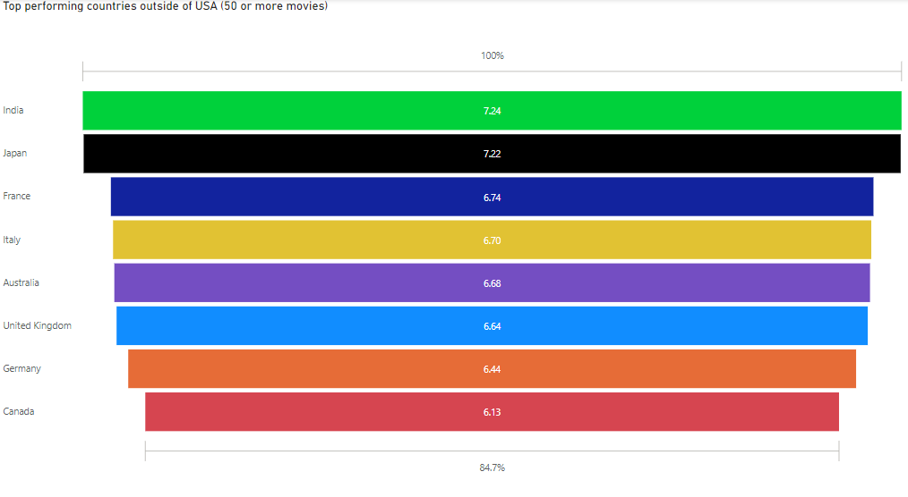

We felt it was important to show what countries are performing the best outside of USA, we knew America would by far produce the most movies in this dataset, so we wanted to remove them for this visual. We decided to do an average score for these countries as it would show which are doing the best according to IMDB, and we also decided that they should have created more than 50 movies. We saw the error when we had no limit, as Lebanon was placed first but had produced an extremely low number of movies at just 1 and was rated an 8.4 which would top this visual, and we thought of it more as an outlier. Also, similarly we wanted these countries to be displayed as making at least 1 movie a year in terms of the movies within this dataset as we felt that best represented the top performing countries.

We feel this gives a particularly good representation of movies around the world as with India producing so many movies but not to the scale of USA. However, we will also highlight after this a representation of these countries again based on profit percentage to compare.

We thought it would be interesting regardless of the ratings, just to see what countries are making the most movies but to make this visual better we incorporated ratings which not only gives us countries who produce a mass number of movies but ones that are good at what they do.

## Percentage profit of the top performing countries outside the USA

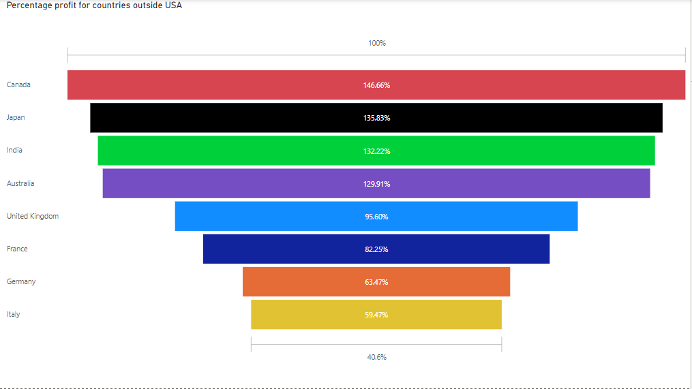

Here is the result when we use the above countries and do not take score into account. A remarkably interesting result, as we see Canada, who had the lowest score of these countries has the highest percentage profit when it comes to making movies. We also see India and Japan stay in the top 3 which shows there dominance outside of the US (United States) in terms of quality and volume of people they can meet over a vast number of movies.

One result we were surprised with between both diagrams was how low the UK (United Kingdom) ranks. We came in with the assumption that USA and the UK would be dominant across the board, but this is not the case. The UK ranks particularly low in both for the number of movies that they make and the score along with the percentage profit on average that these movies are making.

For us, it was not surprising that movies made in Germany and Italy ranked low in the percentage profit diagram. We can conclude that as they would be made in languages that are not spoken by most people in the world it has less reach and results in less revenue being made. For example, movies that are made in Asia have a massive population that can watch it in these languages and thus has a better chance at gaining a large profit.

Overall, we were pleased with our results regarding questions we had that were based around countries outside of the US, it shows little dominance by one country, however, it does show the consistency with Japan and India in terms of quality ratings along with high percentage profits which was an interesting insight.

# The Change in Budget and Gross overtime

We felt it was important to display the budget and gross over this 40-year period. We see all the way back in 1980 that the average budget was still as high as 10 million. We did not think it would be this high, but again we must remember that this is the top 200 movies for that year. We have movies like the blues brothers and heaven's gate that had budgets of 27 million and 44 million, respectively. We see these changes over this 40-year period to just over 53 million. I think some people would expect it to be higher but a reason we thought of it to be just 53 million was the fact that so many movies that are popular these days are low budget(or lower than the likes of marvel etc.) and this causes a lower average than expected, however, still a 523.2% increase over 40 years. People’s interests have slightly changed over the years from blockbuster movies (which are still extremely popular) to movies that get you thinking. A phycological movie that could be made in just one set could only cost 100,000, and with people’s interests changing can still achieve a massive rating and become a top 200 movie over the period of a year.

And when it comes to gross, we still see a 31 million gross average for movies in 1980s compared to a 163.6 million gross in 2020 which is an exceedingly high increase of 527.74% which is very consistent with the increase of the budget overtime. So, we see a relationship between the increase in budget to the gross being a 1% to 1% increases to each other over this 40-year period which is an interesting find. This was interesting, before finding this result we had an assumption of the gross would be much higher than the budget in terms of percentage increase over this period. We were proved wrong, and it led to an interesting finding.

We believe this diagram is extremely easy to read and can really tell a powerful story of the 40-year period.

# Relationship between runtime and other variables

## Relationship between score and runtime

We thought it would it be interesting to see the relationship between runtime and score. Before looking at the data we wanted to know if longer movie runtimes would result in a better score. The reason we came to this question was the fact that any movie we could think of that we thought was a classic or overall, extremely popular was in fact a longer movie than average. We decided to use the key influencer view on power bi to see if we could find a substantial enough difference. In the above diagram we can see that once a movie is under 95 minutes it shows an indication that it is likely to have a lower rating than movies that are longer. There are 2067 movies that are 95 minutes or less and this results in a low average score of 5.94. This is an incredibly low score but let us see if its comparable with the rest of the ranges.

The diagram shows us that the movies that are 126 minutes or above have a higher rating on average. There are 1021 movies made that are 126 minutes or over which results in an average rating of 7.16. There is a 20.5% increase in rating from movies that are 95 minutes or less and movies that are 126 minutes or more. This is an exceptionally significant difference especially when you look at how many movies are included in this analysis.

But why? We wanted to see if we could use the same diagram idea and try to highlight the relationship between the runtime and the budget of movies. We are thinking that logically movies with 126 minutes or more should have a higher budget, but we wanted to see by how much.

## Relationship between runtime and Budget

The second diagram shows the relationship between budget and runtime. Shockingly we see an enormous difference in average budget. For movies with 95 minutes or less, the average budget was 24,249,616 dollars whereas movies with 126 minutes and above had an average budget of 65,071,737 dollars. This is an increase of 168.34% in budget between these movies and results in as explained above a 20.5% increase in the score. Of course, it makes perfect sense that movies with a longer duration on average would cost more than other movies. However, to have a 168% increase on average from movies with 95 minutes to 126 minutes is quite substantial. We also must take into consideration that larger scale movies these days are becoming much longer and may include the so-called Hollywood superstars, which will cost quite a bit of money.

Why we used the key influencer diagram? When researching what new diagrams we could implement into this project the key influencer diagram was present. We saw that we could show the strength and direction of relationships between different variables in our data. It allowed us to trial-and-error variables that we thought may have a relationship. However, before we started the data visualisations this was one of the variable combinations that we expected to have a relationship that would prove to be insightful.

## Relationship between runtime and Gross

Finally, we needed to check the comparison in the grosses of these movies. The diagram above shows the relationship between runtime and the gross of the movies. Again, we see a massive difference. Movies with a runtime of 95 minutes or less have an average gross of 49,675,307 dollars whereas movies with 126 minutes or more have an average gross of 186,017,747 dollars. This shows us a 274.57% increase in the revenue created by these movies which outweighs the average differences in budget which was dominated by the longer movie section. It is interesting that movies that range from 96-102 have a very slight increase from 95 or under, with under 1 million separating them. Although this is an extremely low difference between runtimes we expected a larger difference, but again its insightful as we can see that movies that have a runtime of up to 102 minutes have a much smaller gross and budget as seen previously in the last diagram on page 11.

A simple maths equation can give us the average percentage profit of these two movie runtime ranges.

* 95 minutes or less - 104.84% profit on average.
* 96-102 – 87% profit on average.
* 103-111 – 103.5% profit on average.
* 112-125 – 154.75% profit on average.
* 126 minutes or more - 185.86% profit on average.

Overall, we found this a remarkably interesting piece of analysis on the relationship of runtime with the revenue the score and the budget. We knew originally that there would be a clear indicator to which costs more and so on, however we did not think that the percentage profit would differ in the size that it does. A takeaway from this would be that in simple terms movies that are 126 minutes, or more are more profitable ventures. But with this statement comes many other problems, as a movie maker to try and fall into this upper bracket would take substantially more capital to make the movie itself. Another interesting find was that the movie brackets regarding the runtime seem to show little trend in terms of the first 3 runtime ranges. We see movies that are 95 minutes or less making the most profit percentage on average and seeing no increase for the following two ranges. Once these 3 ranges are passed, we see quite a larger increase which is interesting, and we believe it to be very insightful to our original questions.

# Average rating per year

We thought it would be interesting to see how movies have been rated over the years. We decided to use a line graph for this to highlight the fluctuations in ratings throughout each year. This visual provides us with interesting results again. We see a trend in terms of, as time goes on movies overall are rated better. They seem to peak in 2013-2016 with a bit of a drop off after these years. It is clear that these are small movements in terms of average, however, over a 200-movie period per year it can be important to look at. We decided to not include 2020 movies as there were only 22 movies that had a rating in the dataset and did show a complete plummet in terms of ratings. However, it is interesting that we see a quite large decline in 2019 and we put this down to the COVID-19 pandemic. Although movies were certainly created during this pandemic, higher scale movies were certainly paused in terms of production and release time as it was presumed that it would not be as successful releasing during the pandemic.

# Companies

## Which companies have taken the most gross revenue for the last 40 years?

Another one of our goals in this project was to find out which companies gross the largest amount of money across this 40-year period. The above diagram shows the top 10 companies and shows what each company makes in terms of the top 10. So, this total shows for example 17.24% for Warner Bros. which is of the total of the top 10 companies. We wanted to compare this diagram to one with all the companies involved to see what market share the top 10 companies have. The results are shown below:

1. Warner bros – 9.71%
2. Universal Pictures – 9.03%
3. Columbia Pictures – 7.39%
4. Paramount Pictures – 6.96%
5. Twentieth Century – 6.92%
6. Walt Disney – 6.25%
7. New Line Cinema – 3.42%
8. Marvel – 2.59%
9. Dreamworks – 2.03%
10. Touchstone Pictures – 2%

The top 10 companies over the last 40 years in terms of gross have taken 56.3% of the total gross of movies that are considered in the top 200 movies in each year. This is an astounding result, especially in terms of the top 200 movies each year. These top 10 companies have a majority over the rest of the companies that have been featured in this dataset. We were shocked with this result, and it really shows what companies are creating the market for movies.

Because of this we can focus in on some of the best performing companies in terms of everything to do with movies. We found it interesting throughout to see just how these well-known companies fair and how much of a market share they really occupy. We found that companies like Warner Brothers take up 10.1% of the total budget of top movies created over the last 40 years! Along with them universal Pictures is also the same with just under 10%. They also take 9.7% and 9.01% respectively of the total revenue taken in from the top 200 movies each year over a 40-year period. This is quite the fact, between them they have almost 20% of the market share when it comes to revenue and budget of the top 200 movies produced every year over 40 years! These are some of the things we were curious about before starting this project and to see companies dominate this market so much at the absolute pinnacle of movies is so interesting.

## Top 10 companies based on production

First, we wanted to showcase the top producing companies based on how many movies these companies have made over the last 40 years. Here are the top 10 companies. We wanted to use this as a focal point to the rest of our questions. As we can see the lowest number of movies produced in the top 10 is 94. For the next few questions, we will not use these same companies but companies that have produced 50 or more movies over the last 40 years and see if there are many changes to this order. The reason we have decided this is because we felt that we wanted to deal with companies that are very prominent within this data so we wanted a company that is making close to 2 movies a year to see what insights we can find out about the top producing companies in the top 200 movies each year.

To do this we will do something like the director’s section. We want to see which companies with 50 or more movies have the highest gross, budget and percentage profit on average. These questions were clear to us when we began the project and knew would bring clear and interesting results as the data was made for these types of calculations.

## Top companies gross on average with 50 or more movies

When we change the number of movies produced to a minimum of 50, we see a slight change in the top 10. 9 of the previous top 10 based on production frequency remain in the top 10. TriStar drop out of the top 10 with Dreamworks is now also in the top 10. Interestingly we see that Dreamworks goes to 4th position in the highest average budget which we thought was interesting as it creates a smaller number of movies. But, with 9 of the top 10 producers remaining in the top 10 for gross we think that is interesting and would like to see how it features when companies only make 10 movies to see if there is a strong relationship for the more movies created the more on average the budget will be for that company.

## The top 10 companies with the largest on average budget with 50 or more movies

Similarly, we see the same companies remain as we did with the gross in the budget section. TriStar is still not included even though they created the 10th most movies over this 40-year period. There was a very small change in this budget section compared to the gross section. We see a few companies swap places; however, the top 4 companies stay exactly where they were in the gross diagram which is interesting. Universal Pictures falls two places where Columbia Pictures and paramount pictures climbs one place each. These diagrams are simple but do not tell the full story, we are now going to look at the top performing companies in terms of percentage profit. We also see Disney have quite a larger budget on average compared to all the other companies.

With all these diagrams we used the filter functionality on powerbi to set the number of movies using the count of them to 50 or greater. We also used advanced filtering within the company section to apply the top 10 based on the average gross or budget. This applies to all of sections including directors etc.

## Average Percentage Profit for all companies with 50 or more movies

This was the most interesting part of this project. We wanted to include 20 companies in this diagram in order to get the full picture, and to see more of our top 10 companies from previous diagrams. The highest performing company in terms of profit percentage is Fox Searchlight Pictures. This was extremely surprising, we wanted to investigate the data and see was their mistakes, but what we found was impressive. Fox Searchlight produce movies for budgets that are so low compared to the other companies, for example their top performing movie was a movie that cost 40000 to produce and grossed 40 million, this was obviously an outlier for them, but they perform very high when it comes to profit percentage and bring in well over 100% per movie. To do this consistently over 57 movies, it is rather impressive. Again, we used the filter of having over 50 movies and see so many more companies that may not be as known but are still producing quite a large number of movies at a very profitable rate. One thing to note about this diagram is that the companies that are highlighted in light blue are companies that have not been included in the past few diagrams whereas the other colours are taken from the other diagrams, keeping the colours consistent for ease of viewing.

The line that is included in the diagram is there to showcase the number of movies that each of these companies created over this period which adds a bit more insight into the diagram. We decided that the most impressive company was Universal Pictures. The reason we came to this conclusion was that the amount of movies that they create is far more than others that are in the top ten and yet they place 4th in terms of percentage profit which is very impressive.

One thing we were pleased to see is that all of our companies that were included in the previous 3 diagrams are in the top 19 companies overall here including TriStar which fell out of the top 10 in the previous two diagrams. I think a main takeaway for us is that the companies that do produce the most movies, although may not have the higher percentage profit they perform at the highest of levels when it comes to gross and budget, while also performing extremely high in the percentage profit area also. Companies that produce more indie films and low budget movies have chances to earn an exceedingly high percentage profit and if this can be done successively over a few movies it can help them break into this top 20. However large companies such as marvel for example are not included here as they do not create enough movies over this 40-year period which are included in the data.

We think it is important to highlight just why we decided to have a minimum number of movies created over this period. Just to give an example B24 is another company that would be first in all of these diagrams as it has created one movies which grossed 880 million which was spectre who starred Daniel Craig, when it comes to top movies which this dataset deals with, it is important to highlight the companies who are performing at the highest level and that is why we created this minimum quota.

# Genres

## What genre is most dominant in terms of movies being made?

### 1980-2020

When it came to this topic of conversation of genres over this period, we thought it would be interesting to use a slider for this diagram. We were quite surprised that comedy genre was the top genre in this dataset. So, we wanted to investigate some more. As comedy was first, we decided to show multiple diagrams in our report to display time periods. So of course, first we wanted to show that the whole period was important again as a focal point.

We see that the top 3 genres take up over 71% of the total amount of movies made over this 40-year period but we predict that there will be a momentous change when we focus on smaller more recent years as the development of genres and popularity has changed over the last decade.

### 2000-2020

We see that comedy was extremely dominant of the market with almost 30% over the whole period but when we filter it to newer movies it drops almost 5% of its market share which was quite a lot. This was something we expected as when we think of top movies that are current, many of them are not comedy movies. We see action movies gain about 2% which still leaves it just behind comedy, but the other genres are starting to catch up now and more movies are becoming less of a standard movie as they begin to branch out into diverse types of movies.

### 2015 – 2020

When we go as current as we think is viable, which we decided on a 5-year period to highlight just what are movies like today. We see a massive change from the overall period to this 5-year period. Comedy, which was the top genre was now in 3rd place losing 36% of the share it had and dropped to just 17.85% of movies, this shows how comedy are falling out of favour these days and that dramas have become much more popular along with action movies. Biography movies have almost doubled in its share from 5.78% to 10.83% over the last 5 years. We believe this is showing the current way people like to watch things they either want high intensity action or something they can relate to in terms dramas and the realness of biographies/ true stories. It is an interesting finding and I think we will see over the next 5 years that comedy may fall a lot lower in this section especially for top movies.

Surprisingly, we still see the top 3 genres take up over 64% of the total amount of movies created over this 5-year period which is the most recent. We were quite surprised with this result as we thought it would be much less, but it just shows us how the longevity of these genres is.

I think from these displays of diagrams regarding genres we get a full picture of how the movie industry is. Absolutely dominant in terms of these 3 genres and although it has dropped slightly, it remains at well over half of the top movies being these top 3 genres.

# Conclusion

Throughout the report we have answered all the questions that we wished to do from the beginning. Using power bi we are incredibly pleased with this report. We found a lot of information on the top directors and countries worldwide along with showing a key influencer when it comes to runtime. We found the most profitable movie of all time was a very well-known movie in Paranormal Activity to our surprise, as there are so many low scaled movies that when it comes to percentage profit could have dominated in that area. We believe that our use of powerbi was very intuitive and were delighted to complete all these diagrams on one tool which as definitely improved our skill on this platform and our efficiency. Overall, we are happy with this project and feel that we have given some insight into the movie industry, and for us it was very insightful regarding our interest in this topic.

We think when we look at this project as an analysis of a chosen dataset, we have analysed this dataset to its maximum capabilities. We set out questions at the beginning and feel we have answered them and more. We created an insight into the movie industry that we believe is easy to interpret from our diagrams and made even easier without explanations.